Process to create AD

* 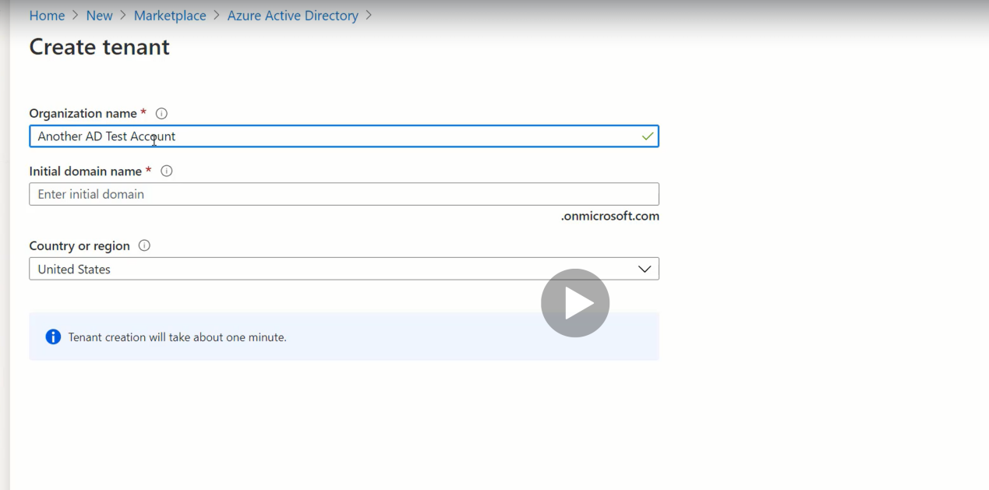
* Switch directory button can be used to switch directories after its creation.
* This will bring you to a fresh tenent with all the new settings.

Access Azure AD

* This is how Webapps works with Azure AD